DOCUMENTATION

**DETAILS**

**TEAM MEMBERS**: TEJAS MURALIDHAR PATIL

R.SREERAM VISHNU

P.KADAR RAJA

M.NIJANTHAN

**DEGREE/BRANCH**: B.E/CIVIL ENGINEERING

**INSTITUTE NAME**: VELAMMAL COLLEGE OF ENGINEERING AND TECHNOLOGY VIRAGNOOR MADURAI-625 009

**SKILLS**: DIGITAL MARKETING

**Project Details**

**Mail**

* **E-mail**: kk.construction1999@gmail.com
* **Password**: okgoogle

**Canva**

* **Brand Name**: kk Construction
* **Canva URL**:

https://www.canva.com/design/DAFybDsmGCQ/dlumzm0Hux9msFgQw0a6TQ/view?utm_content=DAFybDsmGCQ&utm_campaign=designshare&utm_medium=link&utm_source=editor

Creating a mail id

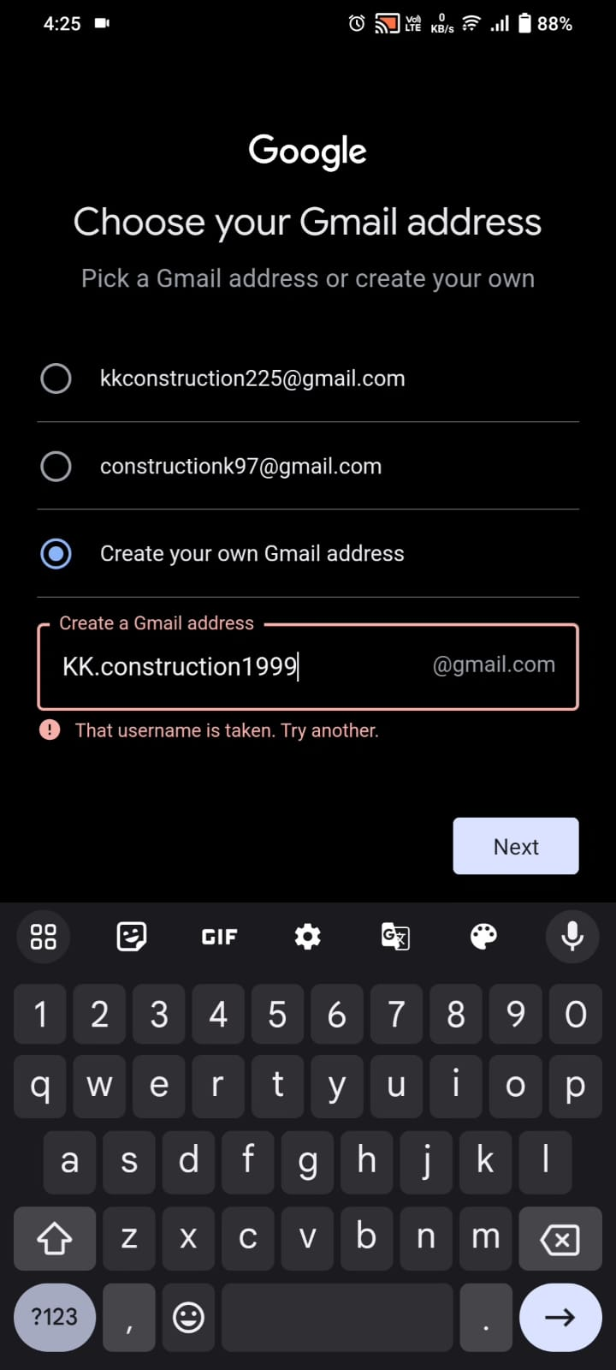

Opening the Canva site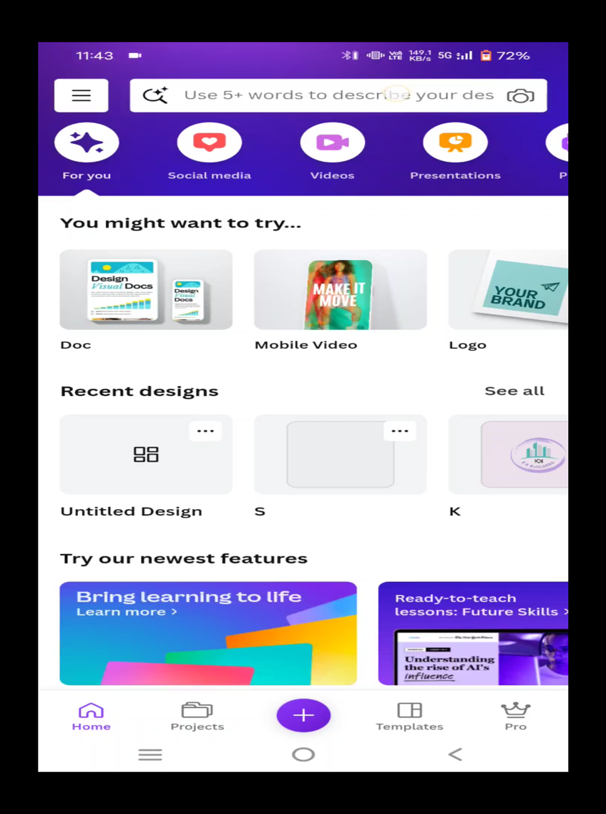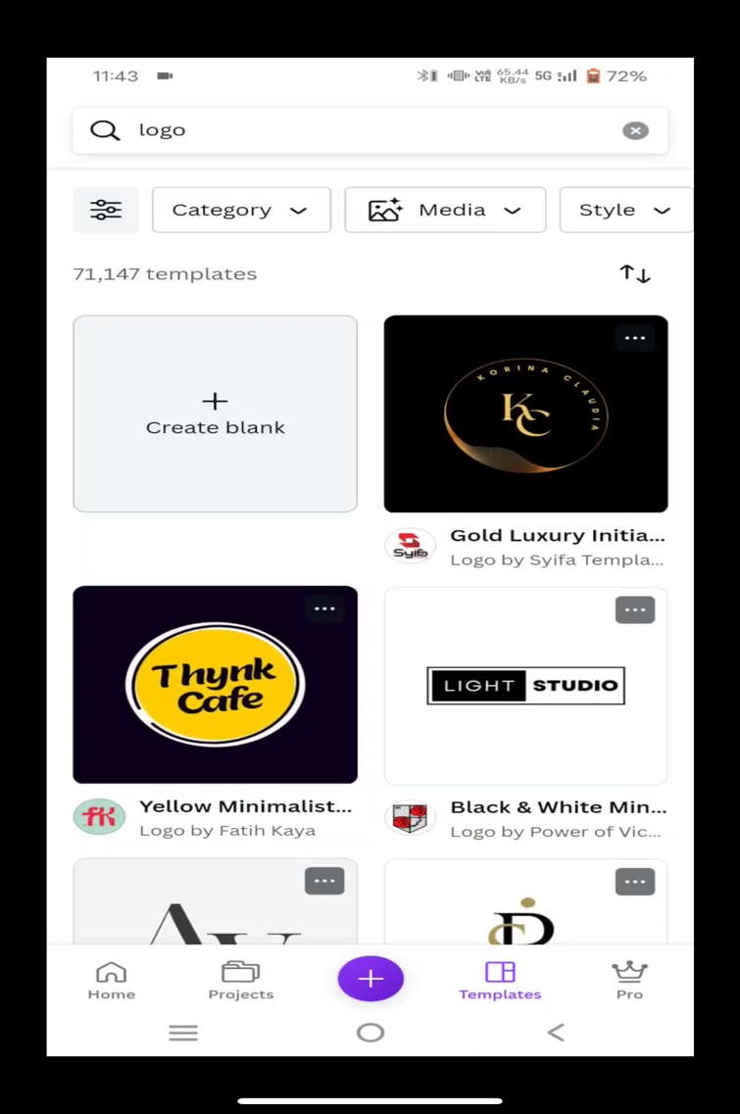

Opening a blank logo template



Selecting Background Shape

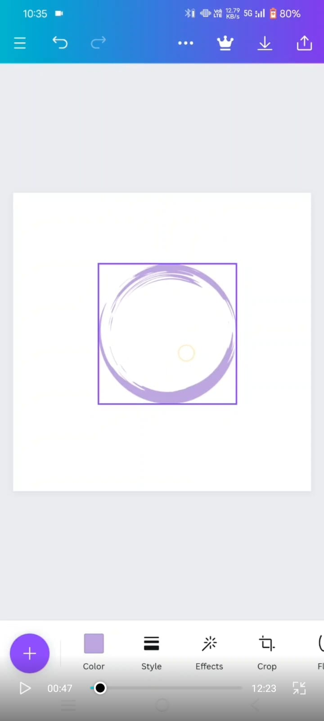

Selecting Background Image

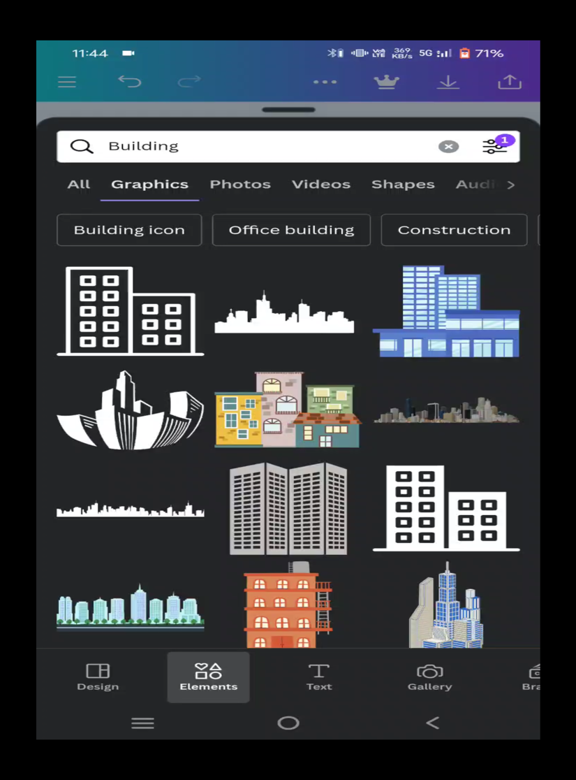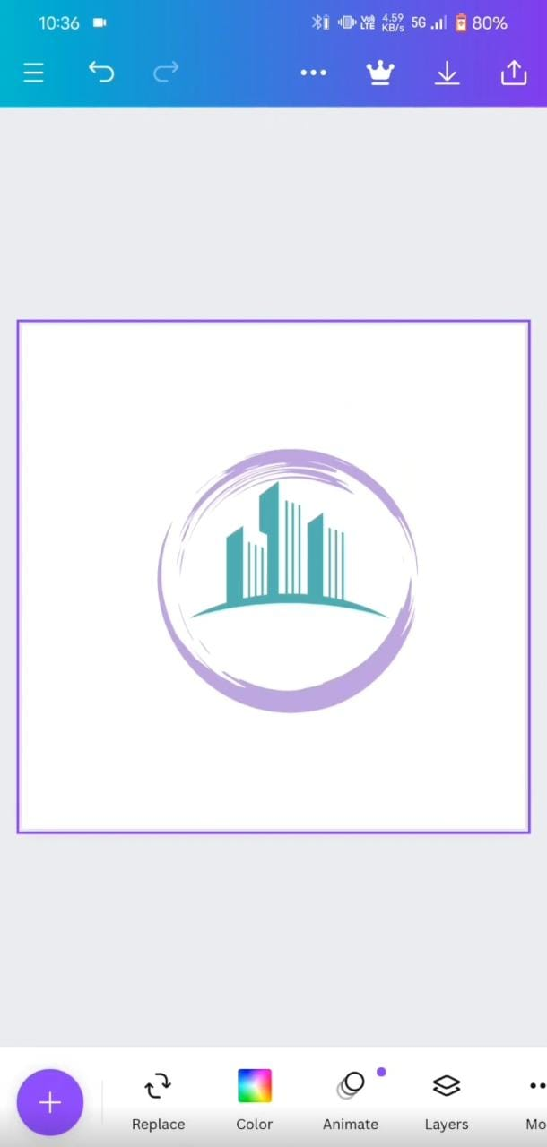

Choosing Letter for Logo and Font

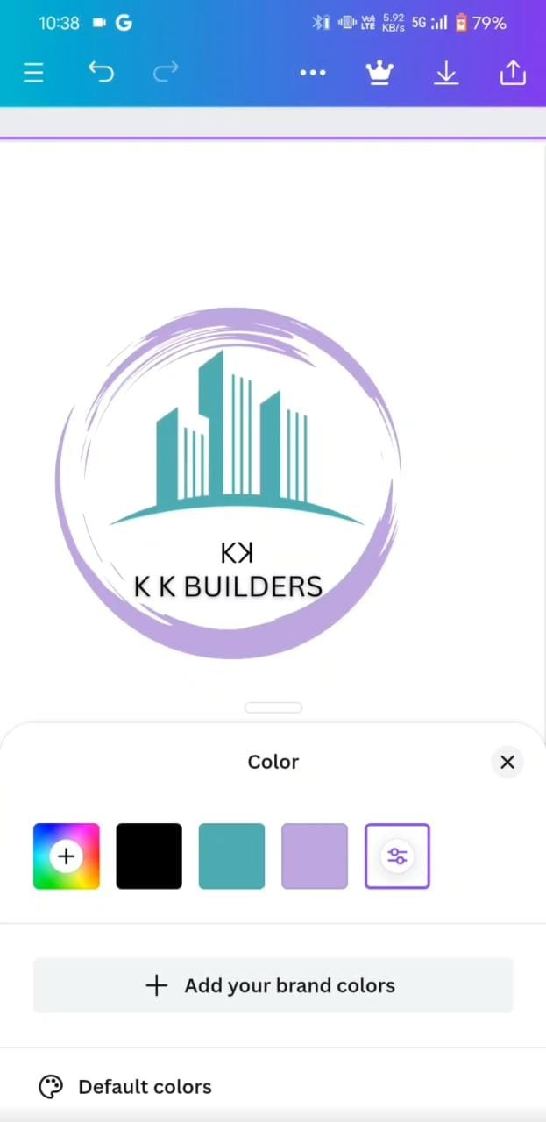

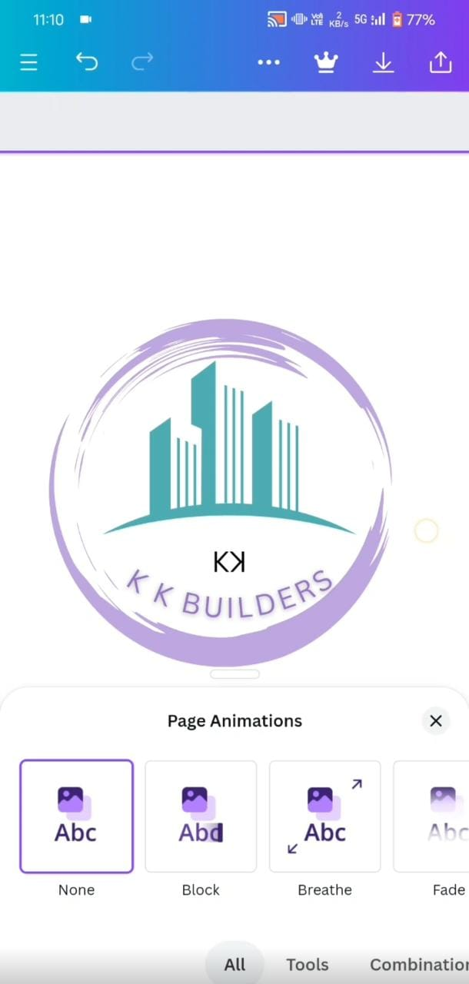 Inserting Our Brand Name and Font

# Our Final Logo Output

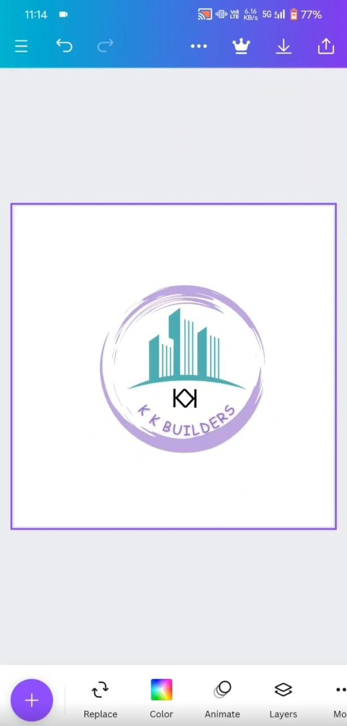

Uploading the video in youtube

